Voter Suppression and a Look into Minority Voters

## [Miro Board](https://miro.com/welcomeonboard/zGYu7wF6zM5btMX7YIN1DVysjeXlup4qXZRfUOhOyQBPM7DfgEIfg1Xizk5R5eGa)

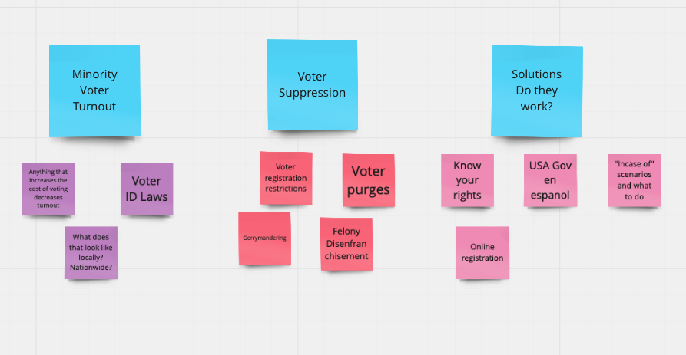

# Voter ID Laws: The Disenfranchisement of Minority Voters?

<http://search.ebscohost.com/login.aspx?direct=true&db=a9h&AN=135474067&authtype=shib&site=ehost-live&custid=s8989762>

# USA gov en espanol

# Voter Suppression Is Warping Democracy

<https://www.theatlantic.com/politics/archive/2018/07/poll-prri-voter-suppression/565355/>

# Does State Online Voter Registration Increase Voter Turnout?*. (yes it does)

<http://search.ebscohost.com/login.aspx?direct=true&db=a9h&AN=135896684&authtype=shib&site=ehost-live&custid=s8989762>

# Block the Vote: Voter Suppression in 2020

Voter suppression in the 2020 election and how that impacts minorities.

<https://www.aclu.org/news/civil-liberties/block-the-vote-voter-suppression-in-2020/>

# Know your rights

<https://www.aclu.org/know-your-rights/voting-rights/#someone-is-interfering-with-my-right-to-vote>

